Robotics Schedule

Meetings Tuesday from 2:40-4pm

September 11

September 18

September 25

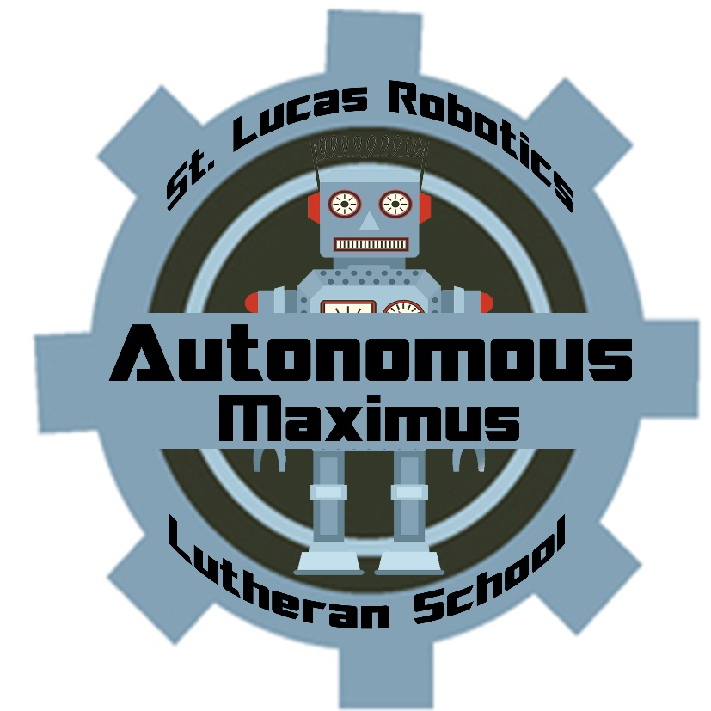October 2

October 9th – NO ROBOTICS

October 16

October 23

October 30

November 6

November 13

November 20

November 27

December 4

December 11

December 18

January 8

January 15

Saturday, January 19, Appleton Tournament

January 22

January 29

February 5

February 12

Saturday, February 16, McFarland Tournament

February 19, Last Day of Robotics (party and sorting)